**Department of Computing**

**EC-303: Mobile Application Development Class: BESE 11AB**

# Lab 04: Flutter Basics – Widgets, Material Design, Layouts, and Interactivity

**CLO 2: Use advanced design and development techniques for developing data-driven Mobile Interfaces**

**Date: 27-Feb-2024**

**Time: 10:00 AM - 12:50 PM**

## 

## Instructor: Ms. Naema Asif Lab Engineer: Mr. Aftab Farooq

**Lab 4: Flutter Widgets, Layouts , Material Design & Interactivity**

**Objectives**

This lab will get students familiar basics of Flutter Widgets, Material Design, Layouts and Interactivity.

**Topics to be Covered**

* Flutter Hello World
* Widgets
* Material Design and Layout Concepts
* Adding Interactivity to your Flutter App

**Tools/Software Requirement**

* Flutter SDK
* Android Studio
* VS Code
* <https://flutlab.io/>

**Lab Tasks**

**Task # 1**

Follow the guidelines mentioned in <https://codelabs.developers.google.com/codelabs/first-flutter-app-pt1> and follow the step-by-step tutorial.

**Task 1: Deliverables**

Zip the source code from following steps and upload it on LMS

* [Step 3](https://codelabs.developers.google.com/codelabs/first-flutter-app-pt1#2)
* [Step 4](https://codelabs.developers.google.com/codelabs/first-flutter-app-pt1#3)
* [Step 5](https://codelabs.developers.google.com/codelabs/first-flutter-app-pt1#4)
* [Step 6](https://codelabs.developers.google.com/codelabs/first-flutter-app-pt1#5)

**Task # 2**

Follow the guidelines mentioned in <https://codelabs.developers.google.com/codelabs/mdc-101-flutter> and follow the step-by-step tutorial.

**Task 2: Deliverables**

Zip the source code from following steps and upload it on LMS

* [Step 3](https://codelabs.developers.google.com/codelabs/mdc-101-flutter#2)
* [Step 4](https://codelabs.developers.google.com/codelabs/mdc-101-flutter#3)
* [Step 5](https://codelabs.developers.google.com/codelabs/mdc-101-flutter#4)

**Task # 3**

Follow the guidelines mentioned in <https://codelabs.developers.google.com/codelabs/first-flutter-app-pt2> and follow the step-by-step tutorial.

You might need to reuse the codebase from [Task#1](https://codelabs.developers.google.com/codelabs/first-flutter-app-pt1)

## Task 1: Deliverables

Zip the source code from following steps and upload it on LMS

* [Step 3](https://codelabs.developers.google.com/codelabs/first-flutter-app-pt2#2)
* [Step 4](https://codelabs.developers.google.com/codelabs/first-flutter-app-pt2#3)
* [Step 5](https://codelabs.developers.google.com/codelabs/first-flutter-app-pt2#4)
* [Step 6](https://codelabs.developers.google.com/codelabs/first-flutter-app-pt2#5)
* [Step 7](https://codelabs.developers.google.com/codelabs/first-flutter-app-pt2#6)

**Task # 4**

1. Create a screen as shown below
2. Add a Label and Add Two Buttons i.e. Increment & Decrement
3. When user press the + button the value increments by 1
4. When user press the – button the value decrement by 1
5. Initially the decrement button is disabled and value of label is 0.
6. When user presses the increment button value of label is increment by 1 and both buttons are enabled.
7. Disable the Increment button when number reaches to 10 and show message to user in Alert Dialog that you cannot increment more.
8. Similarly disable the Decrement button when numbers reaches to 1. Show message to user in Alert Dialog that you cannot decrement more.

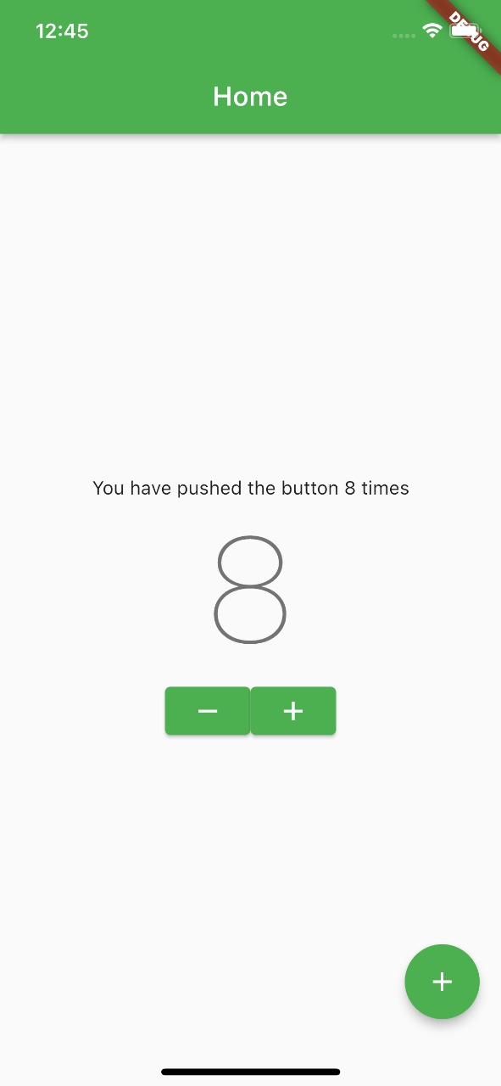

**Useful Resources**

Below is the list of useful resources to help you in solving this task:

1. Introduction to Widgets: <https://docs.flutter.dev/development/ui/widgets-intro>
2. Flutter Widgets Index: <https://docs.flutter.dev/reference/widgets>
3. Layouts in Flutter: <https://docs.flutter.dev/development/ui/layout>
4. Layout Concepts in Flutter: <https://docs.flutter.dev/codelabs/layout-basics>
5. Combining Different Layout Approaches: <https://docs.flutter.dev/development/ui/layout/tutorial>

**Deliverables and other information:**

* Compile a single word document by filling in the solution part and submit this Word file on LMS.
* Push your work on Git hub and add the link in report. Make sure that the repo is public.
* The name of the zip file should be: **your-name_class_cms-id_lab-4.zip**   
  (example: Muhammad-Farooq_ bsse-9_311133_lab-4.zip)
* This lab is graded between 0 to 10 marks.
* Marks will be deducted in case if any functionality is incomplete, missing, or code is not compiling.
* 2 marks will be deducted in case the deliverables are uploaded in an unacceptable format.
* Late submissions will also result in deducting 2 marks.
* You will be awarded a zero if you fail to submit the task.
* At the end of each lab or in the next lab, there will be a viva/quiz related to the tasks.
* In case of any problems with submissions on LMS, submit your Lab assignments by emailing it to Mr. Aftab Farooq: [aftab.farooq@seecs.edu.pk.](mailto:aftab.farooq@seecs.edu.pk)